Technical Appendix Tartigrade Group A

**Python Code:**

**Function:** The Prototype will consist of individual codes that will be put together. Each of these individual codes will determine a relationship between Tartigrade’s net/gross profits, number of trades and market variables assigned to the individual. Once together, the prototype will take all these findings into account and show what happens to net/gross profits and contracts when any of the market variables shifts. This will not just be cumulative effects of the market variables as they impact each other which requires for the prototype to account for indirect effects on these target variables. For example, interest rates, while not correlated with the target variables directly, affect VIX and SPY which have been found to have correlation with the targets. If there is time, this code will be modified to include visualization in the form of a dashboard to ease interpretation for those not familiar with the data.

*A1: Sample of Python Code which conducts OLS Regression:*

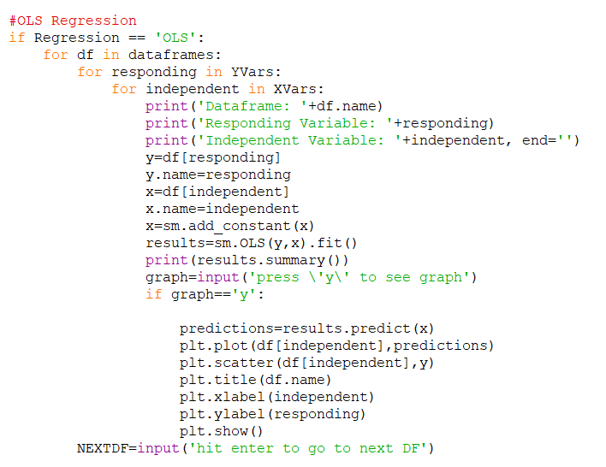

*A2: Sample of Python Code which sets up LASSO Regression*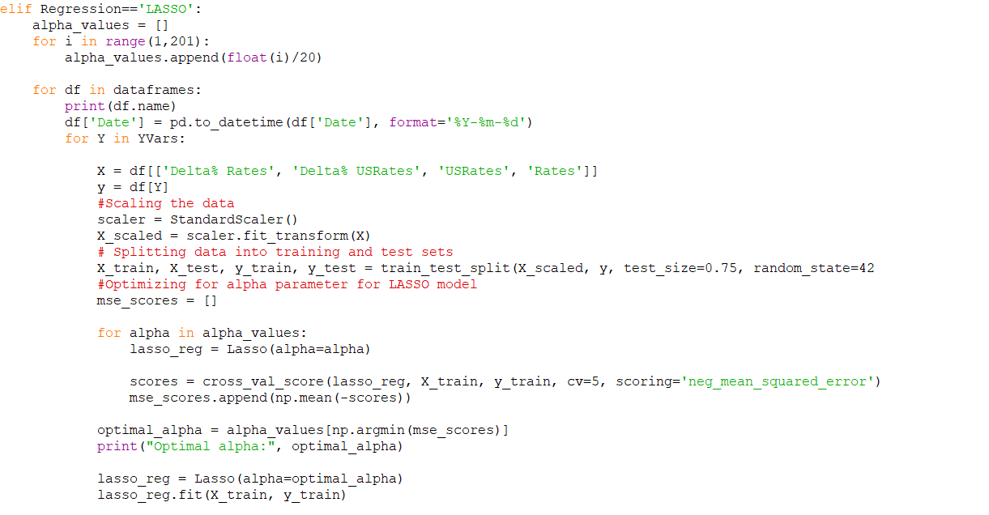

*A3: Sample of Python Code which visualizes and prints coefficients from LASSO Regression:*

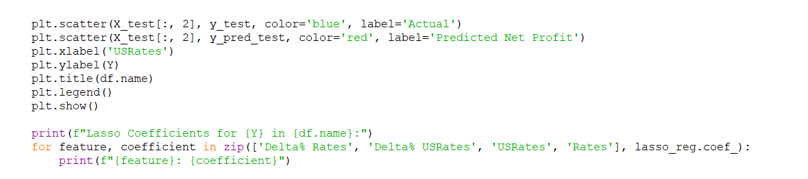

**Data:** Early versions of this prototype will accept .csv files of data which will be merged on the date/time of the trades. Because the data needs to be merged, significant parts of the code will be dedicated to cleaning it. Later versions will connect directly to Tartigrade’s SQL server and to our personalized database which will contain all market variables we will use. This will remove the need for cleaning and merging.

*A4: Sample of Python Code which connects to the SQL server and conduct queries in Python*

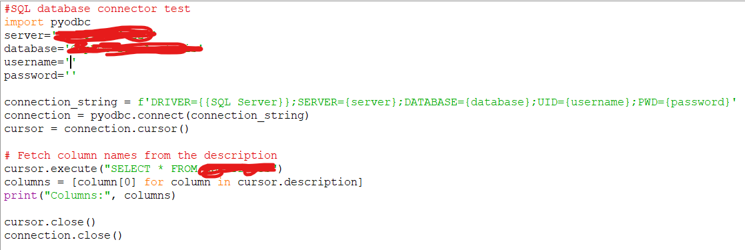

**Dashboard**: The primary deliverable of this project as previously stated consists of a PowerBI or Seaborn and Matplotlib dashboard honed to deliver unknown insights into the behavior of their current trading algorithm/model. Tartigrade has requested said dashboard to be easily configurable so future trades can be added at their convenience.

*A5: Sample of Requested Dashboard (PowerBI), (Values hidden per IP protection)*

